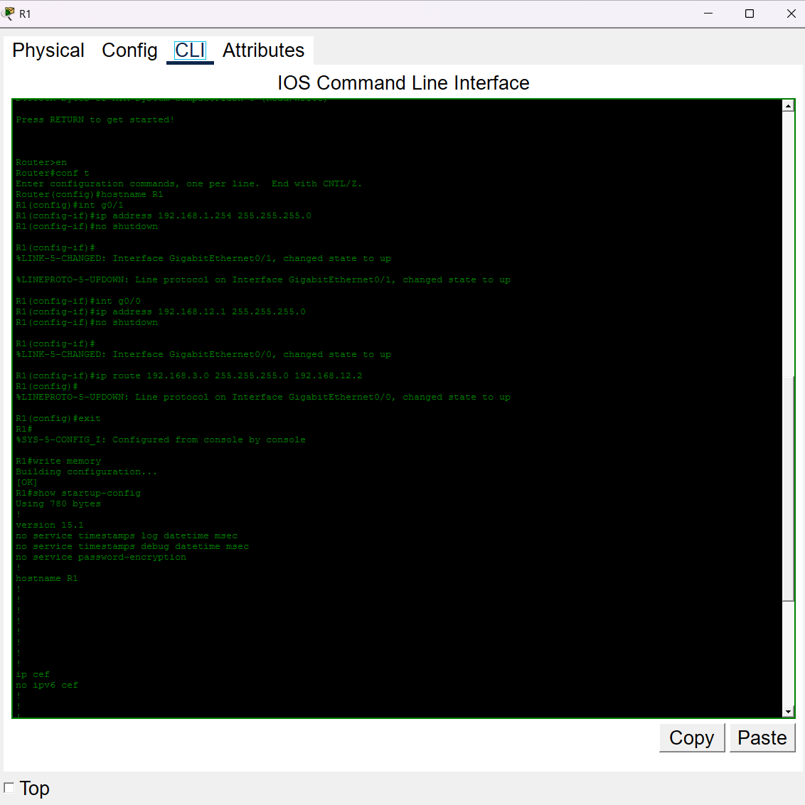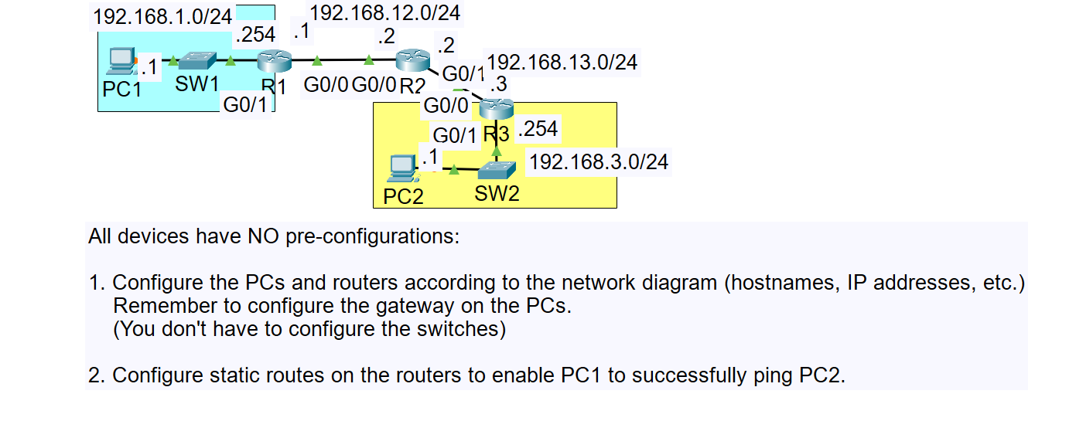Cisco Packet Tracer Lab 01:

**Figure 2 R1 CLI**

**Figure 1 Network Topology**

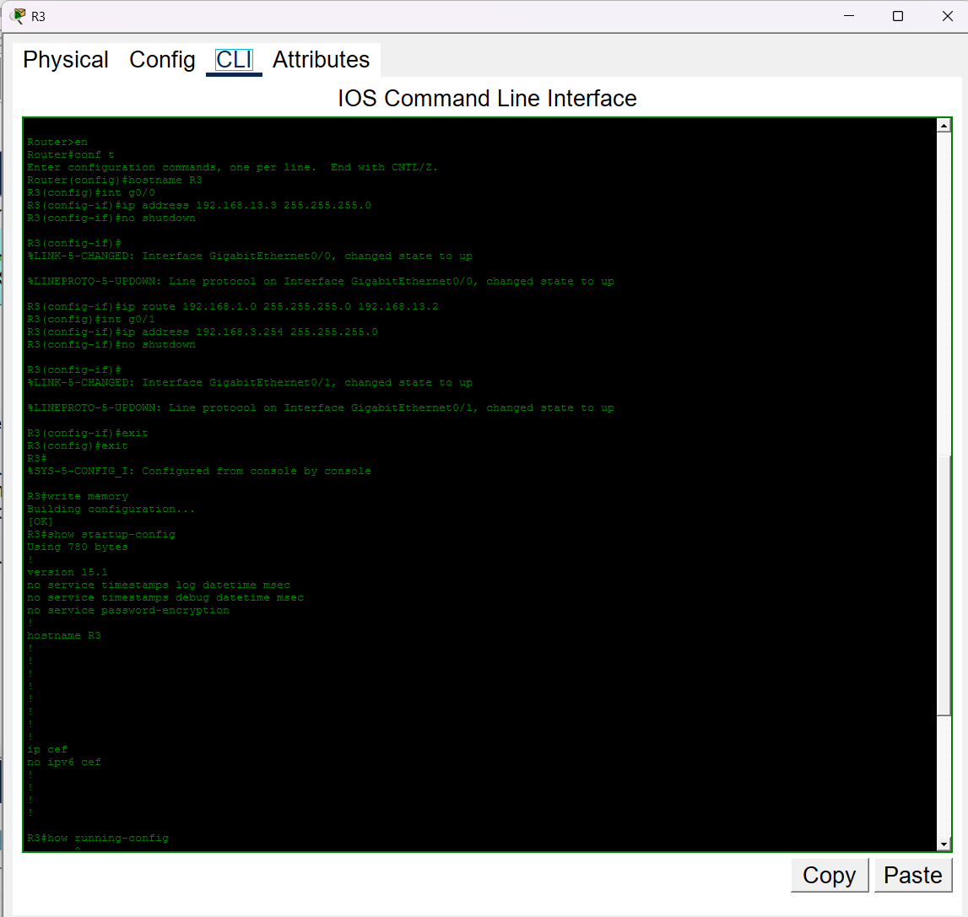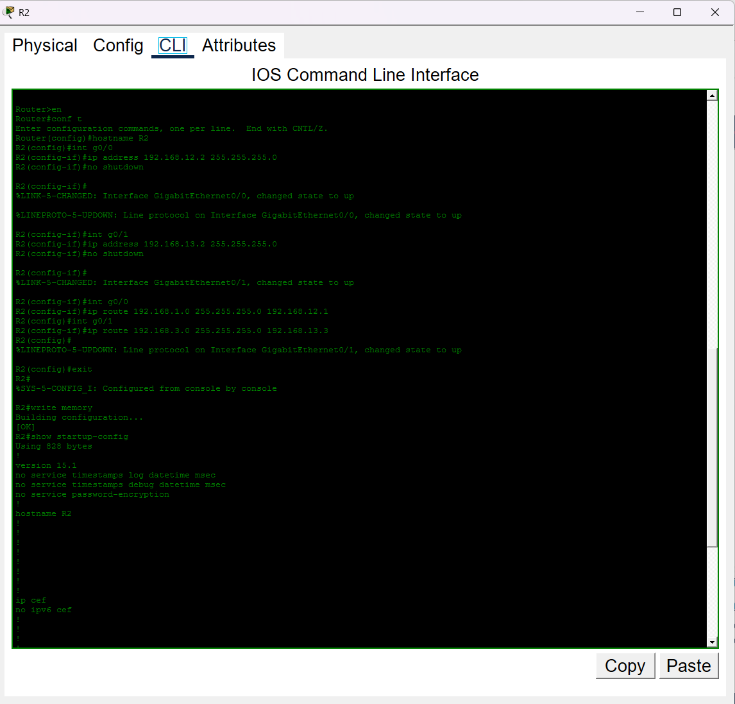

**Figure 4 R3 CLI**

**Figure 3 R2 CLI**

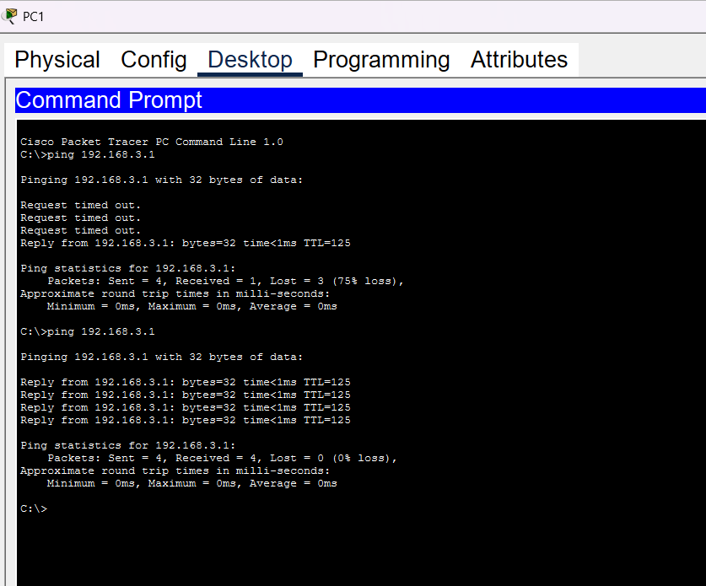

**Figure 5 PC1 Command Prompt**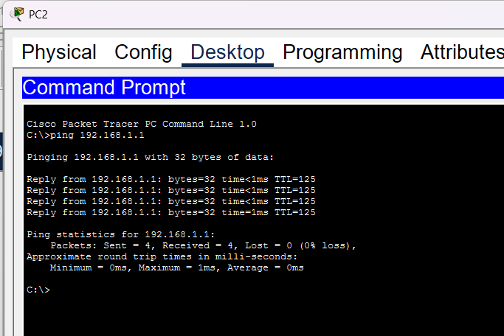

**Figure 6 PC2 Command Prompt**